Studio PDR Planning Worksheet
Learning outcome 1
Select and apply industry-standard tools and processes to solve non-trivial problems in a team environment.
Objectives:
- Contribute to development of new product features
- Contribute to project deployment
- Contribute to CI/CD solution
- Demonstrate improvements in applying Agile project management
- Use industry-standard communication and project management tools in a professional manner

Learning outcome 2
Analyse and manage development challenges to create production-quality outputs.
Objectives:
- Contribute to automated test suite
- Perform a security audit to identify potential vulnerabilities
- Participate in code/solution review to ensure high-quality outputs

Name: Logan J. Olding
Date of scheduled PDR meeting: Practice / Final
Discussed with:
What are your personal goals and objectives in addition to the course objectives?
I am trying to improve my communication skills and communicating more out of class through either email or teams.
What has gone well? What are your strengths?
Debugging weird problems. My strengths still lie in doing actual programming though I would have liked to do more coding.
What could have gone better and how?
My team communication was lacking and sprint planning was a bit ambitious. Swapping to velocity point based planning helped near the end.
Additionally I spent too long helping teammates instead of doing actual coding.
What are the next steps to take? What is your plan for further self-development?
Improve on my teaching skills so I can help my team mates faster so I can get to doing more coding. Teach more.
What barriers exist? How do you plan to deal with them?
Lack of sleep/ Bizarre sleep schedule/ reliance on energy drinks or coffee to stay awake.
What is not clear or is uncertain?
If there is a way to skip one studio to graduate this year and if that’s not possible what additional classes to take next year.

What evidence do you plan to use to demonstrate your completion of the objectives?
- Contribute to development of new product features
I primarily worked on creating the player health page with an injury system
Here is an early prototype of the health page.
This was later expanded on to include allergy/dietary details but the severity sorting system stayed
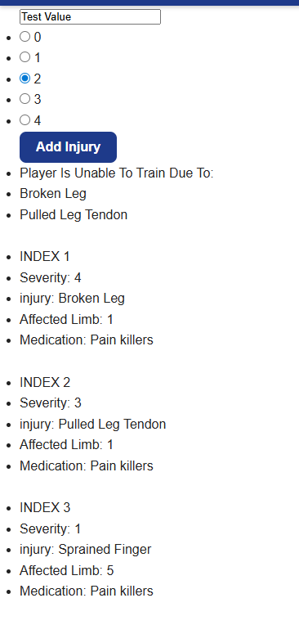

- Contribute to project deployment
I helped debug some render problems with jack. I also ended up creating a basic database baselining thing for render with jack.
https://github.com/BIT-Studio-4/2026s1-football-quality-assured/issues/97

I also helped with setting up the render deploys with separate databases for each setup
https://dashboard.render.com/project/prj-d8cemfcp3tds73dq15m0/environment/evm-d8cemfcp3tds73dq15mg

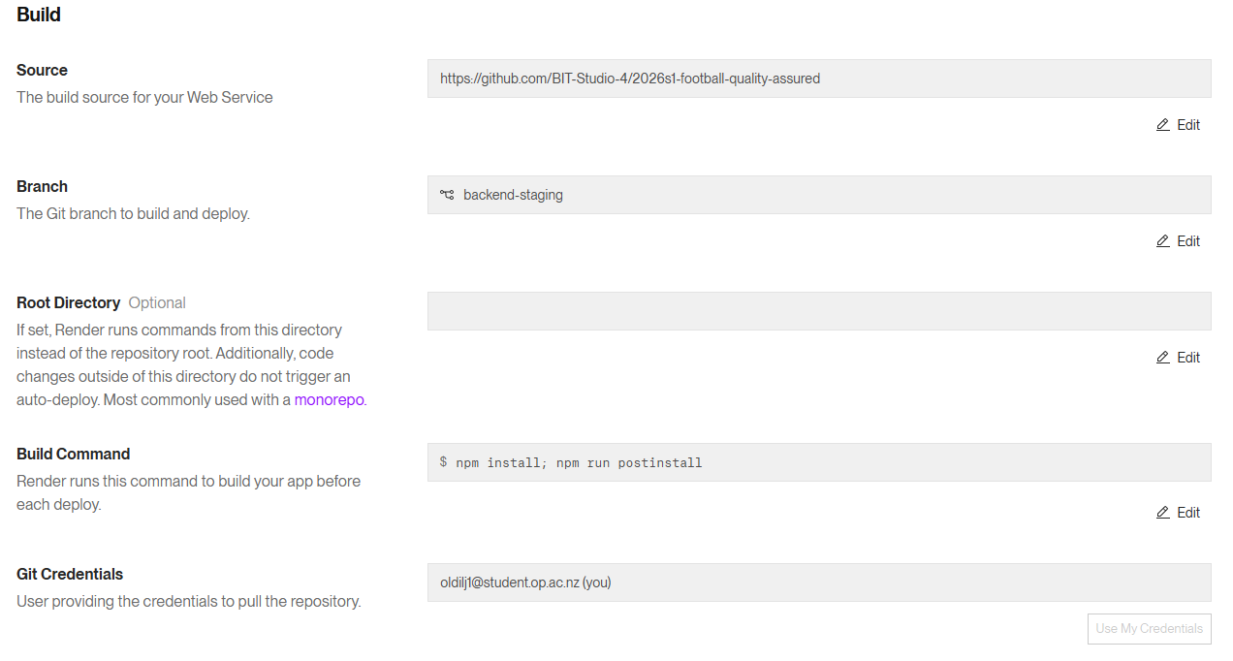
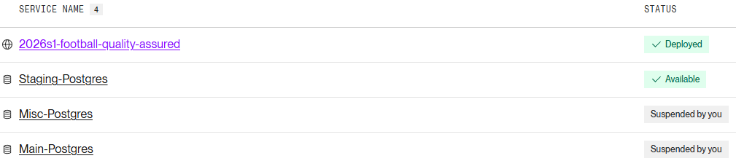

- Contribute to CI/CD solution
I created a quickstart script near the beginning of the project that was used frequently.
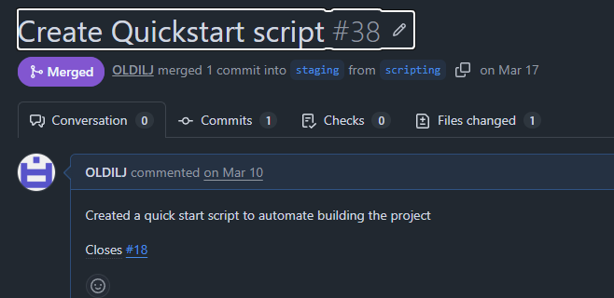
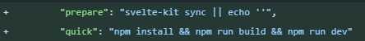
https://github.com/BIT-Studio-4/2026s1-football-quality-assured/pull/38

- Demonstrate improvements in applying Agile project management
Near the start of the project we were over ambitious and did too much work. This lead to us burning out
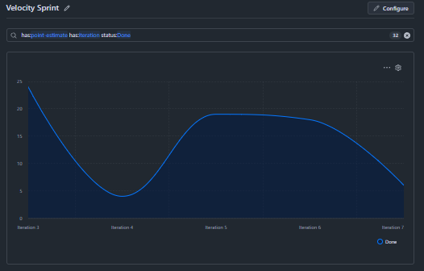
We then reduced our scope and focused on creating more vertical slices alongside carrying over more work from the previous sprints
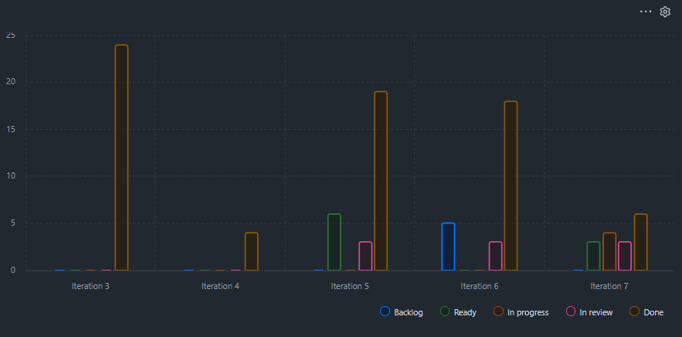
Giving us a nice looking final issue status chart where we have finished the majority of the features we wanted to add.
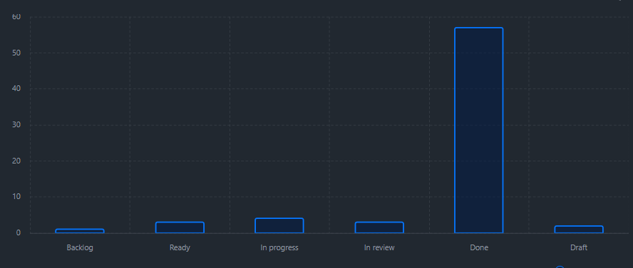

- Use industry-standard communication and project management tools in a professional manner

We primarily used github projects and discord with a few messages sent via teams.
We frequently used discord with us having over 600 messages logged and hosted online standup meetings on days we couldn’t get to class.
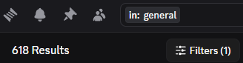

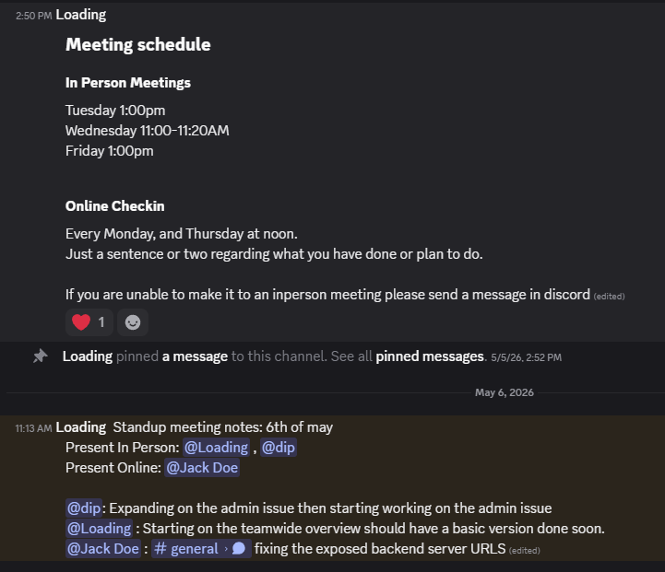

As for github projects we used different tabs for organization reasons with tabs for current, next and previous iterations, two backlogs, each individuals issues and a collection of draft issues to convert into proper issues for the following sprint.

